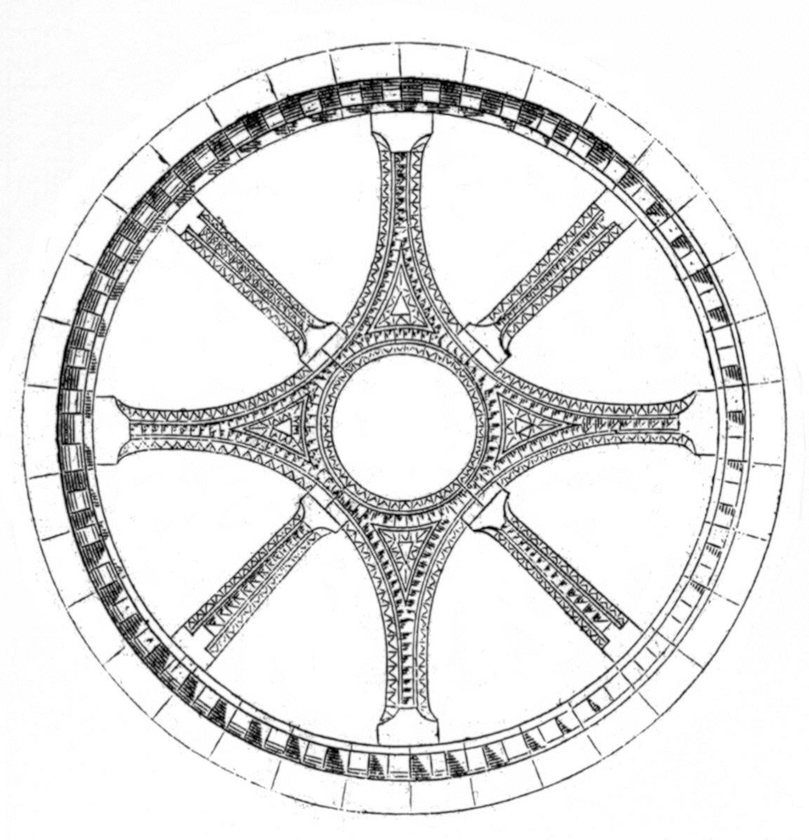
International Medieval Society - Paris
Symposium 2008: “Blood”
24 - 26 June 2008

Registration Form

Name:

Affiliation:

Address:

E-mail:

Please place an X in the boxes that apply to you:

[ ] With this form, I register for the IMS-Paris 2008 Symposium and I agree to pay the required membership fee in Euros (either by cash or check in Euros) on the first day of the Symposium.

[ ] I would like to be added to the IMS Members e-mail listserv.
(ims-members@yahoogroups.com).

[ ] Symposium Speakers Only: I would like to attend the speaker dinner on Wednesday 25 June and agree to pay the fee on the first day of the conference.
(We regret that space limitations restrict the dinner to those giving papers at the conference.)
[ ] I will bring one guest (place numbers are limited, so only one guest please).

Membership Fee Schedule
35 euros: regular rate
25 euros: reduced rate for students, emeriti/ae, independent scholars
100 euros or more: Friends of the Society

Please enclose your check in euros payable to the Société Internationale des Médiévistes
with this registration form. If you do not have a euro bank account, you may pay in cash when you arrive at the Symposium.

Registration will not be considered complete until your fee is received.

Please email this completed form no later than 7 May to contact@ims-paris.org

